4 DAYS 3 NIGHTS KUALA LUMPUR + PENANG PACKAGE

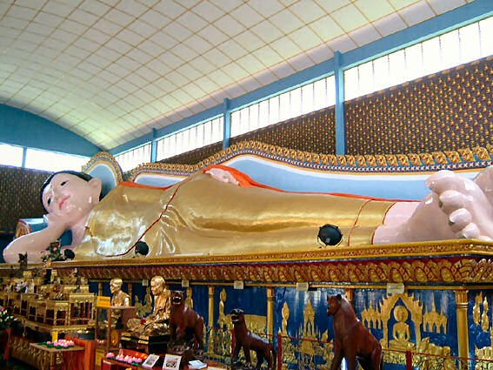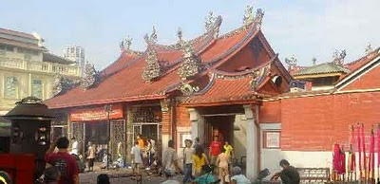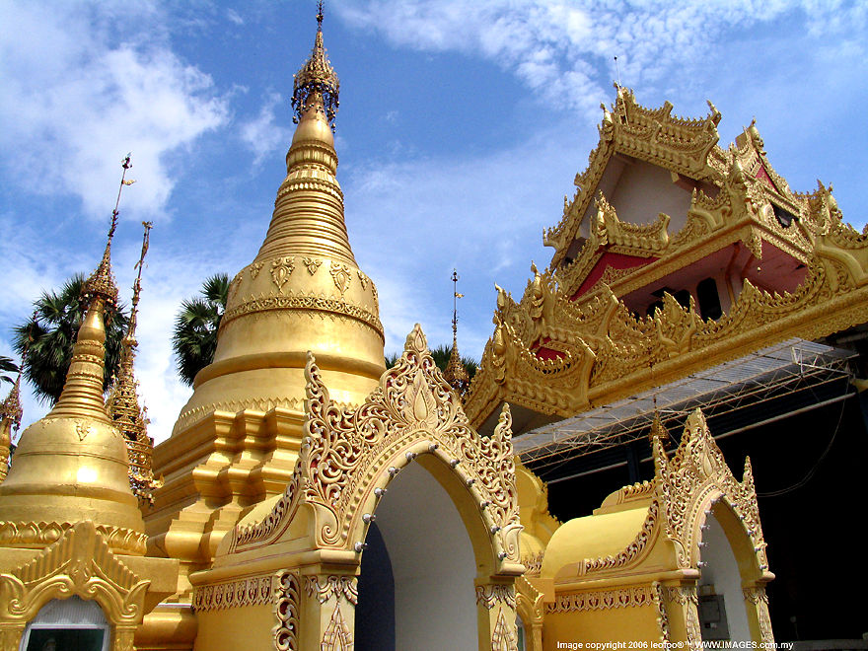

Hotel | Twin / Triple  (per person) | Child with extra bed | Child without bed | Single supplement additional
(3*) Sentral Pudu hotel KUL +  Grand Continental PEN | RM 660.00 | RM 520.00 | RM 390.00 | RM 220.00
(4*) Coronade Hotel KUL +  Copthorne Orchid PEN | RM 790.00 | RM 625.00 | RM 470.00 | RM 345.00
(5*) Maya Hotel KUL +  Paradise beach PEN | RM 885.00 | RM 700.00 | RM 350.00 | RM 440.00

ITINERARY :

Day 1 ARRIVE KUALA LUMPUR
Arrive KUALA LUMPUR airport , transfer to Kuala Lumpur half day City tour – National Monument , Independence Square , National Mosque , King Palace , Petronas Twin Tower ( photo stop) .
After tour , transfer back to hotel , free at own leisure , overnite at Kuala Lumpur hotel .

Day 2 KUALA LUMPUR - PENANG
Brekfast at hotel , arrive Penang airport , transfer to hotel for check in . Overnite at Penang Hotel .

Day 3 PENANG (BREAKFAST)
Breakfast at hotel, proceed to half day tour – visit Reclining Buddha, Dharmmikarana Burmese Temple, Penang’s Milionaries Row, The Goddess of Mercy (Kuan Yin) Temple. Overnite Penang Hotel .

Day 4 PENANG – DEPARTURE (BREAKFAST)
Breakfast at hotel, free until transfer to Airport for your departure from Penang - Kuala Lumpur.

Package Inclusive :
~ Transfer in/out (seat in coach).
~ 3 Nights accommodation (Twin sharing).
~ 3 Hotel Breakfast.
~ Half day Kuala Lumpur &Penang tour (seat in coach)

Package EXCLUDED :
~ Personal expenses
~ Domestic Air ticket
~ Tipping
~ Travel Insurance
~ Entrance fees.

REMARKS :
~ Rate is based on minimum 02 paxs and above.
~ Package is based on SIC basic.
~ Rates subject to change without any notice.
~Validity : Until March 2012 .
~ All rate quoted is base on RINGGIT MALAYSIA

PEAK SEASON SURCHARGE :-
~ Sentral Pudu hotel additional surcharge @ RM 50.00 per room per night on 24 – 26 Dec &
31 Dec – 01 Jan 2012.
~ Coronade Hotel additional surcharge @ RM 35.00 per room per night on 01 – 31 Dec 2011 .
~ Coronade Hotel compulsory dinner on Christmas Eve & Day @ RM 100.00 per adult
~ Coronade Hotel compulsory dinner on New Year @ RM 120.00 per adult .
~ Grand Continental Hotel peak season surcharge @ RM 35.00 per room per night fall on public holiday & school holiday 2012 .
~ Copthorne Orchid hotel peak season surcharge @ RM 50.00 per room per night on 21 Dec – 03 Jan 12 ,
21 Jan – 26 Jan 12 .
~ Paradise Beach Hotel peak season surcharge @ RM 50.00 per room per night on 20 Dec – 05 Jan 12 ,
21 – 27 Jan 12 .

